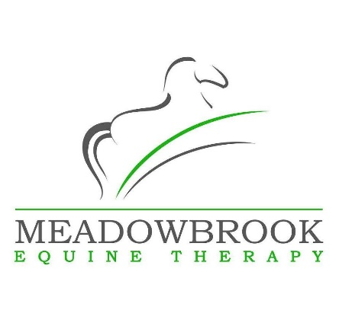
Massage for Horse Owners Certificate
1 day course – syllabus
- Course Introduction
- History of Massage
- Anatomical Terms & Directions
- Equine Skeleton – The Bones
- Equine Musculature – Deep & Superficial
- Tendons & Ligaments
- How the Muscles Work
- The Stay Apparatus
- Equine Fascia
- The Benefits of Massage
- Vital Signs of Health
- Preparing for Massage
- The Foundation Hand Placements & Massage Moves
- Therapist Posture
- Contraindications
- Warm Up/ Cool Down Routine
- Heat & Ice Therapy

